**Name: _______________________________________________ Date: ______________________ Per. _______**

**“Right to Remain Silent”: Miranda v. Arizona – Annenberg Classroom**

1. Where does your “right to remain silent” come from (amendment)?
2. Who is the criminal suspect in this case?
3. What is the most important piece of any criminal trial that prosecutors look for?
4. What is self-incrimination?
5. The Framers were aware that the criminal justice system could be a place where ___________ of power could occur.
6. Which amendments limit the powers of the government when dealing with those accused of crimes?
   1. ________
   2. ________
   3. ________
   4. ________
7. The two sides in our adversarial court system is the __________________________ (the government) and the ___________________________ (representing the accused).
8. Prior to the Miranda case, there was no rule that police officers had to inform people of their ___________ during the interrogation process.
9. The best advice that a criminal suspect can receive is to “shut up and talk to your _______________.” This is to prevent people from incriminating themselves.
10. Ernesto Miranda did not know that he had the right to remain silent and he did not have an attorney until his _______________.
11. The Chief Justice of the Supreme Court during this case was _____________________________.
12. In 1963, the Court heard *Gideon v. Wainwright* that guaranteed people the right to an _____________________ in all criminal trials.
13. In 1964, *Escobedo v. Illinios*, the Court found that criminal suspects have the right to an attorney before the __________________.
14. What does “taking the Fifth” mean?
15. What was the vote of the Supreme Court in the Miranda Decision? _________ to __________.
16. Based on the majority opinion, when would police officers be required to issue the Miranda warnings?
17. This ruling was controversial - Congress disagreed with it and Presidential Candidate, ______________________________________ ran against it during his campaign.

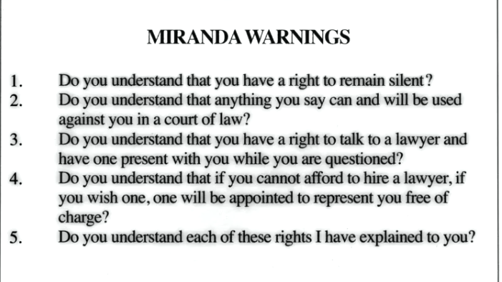

1. Which amendments are referenced in the questions that are asked during the Miranda warnings?
   1. __________
   2. __________
2. In *Dickerson v. United States,* the Court argued that “Miranda” is embedded in the ___________________________________________.
3. Justice Hugo Black argued that the Framers made it intentionally _____________________ to convict people of crimes, and that is a protection for us all.